**Swordfish API Emulator**

**# About Swordfish API**

* The Swordfish emulator allows user to create, read, delete and update Rest operations .
* This Swordfish is an extension of Redfish emulator (“**DMTF REDFISH EMULATOR**”).
* We have to follow some installation steps which are declared in installation documentation.

**# Use of Swordfish**

**Restfull Operations:**

Swordfish supports all restful commands( GET, POST,PUT and DELETE) . To perform these operations we can use Postman or any other add-on.(which is chrome extension)

**Postman:**

Basically postman is supported In chrome browser . We have to create an account in postman and use it for testing rest api.

We can use postman for all rest operations. Below are the figures with description.

1. Using postman we are going to Get “redfish/v1”

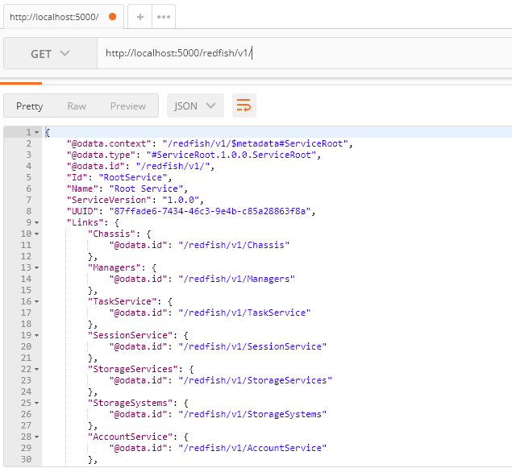

1. “Get” data of Storage-Services

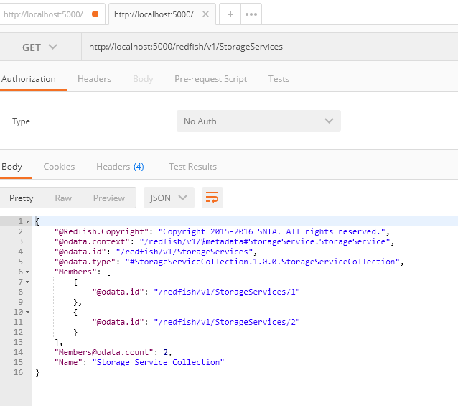

1. Create a new collection using “POST”

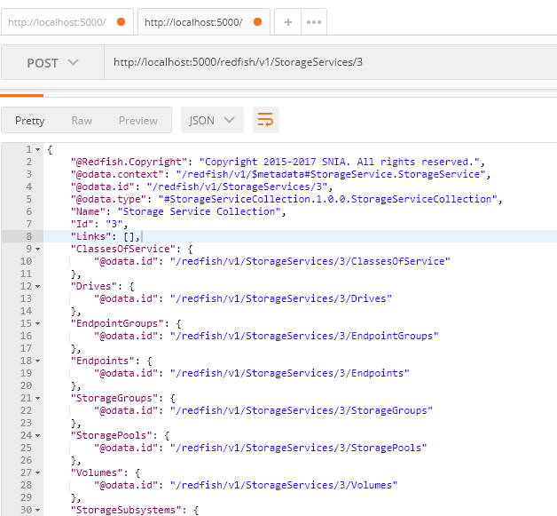

1. Create a new Volume using “Post”

We are creating new child collection i.e .. StorageServices/1/Volumes/1

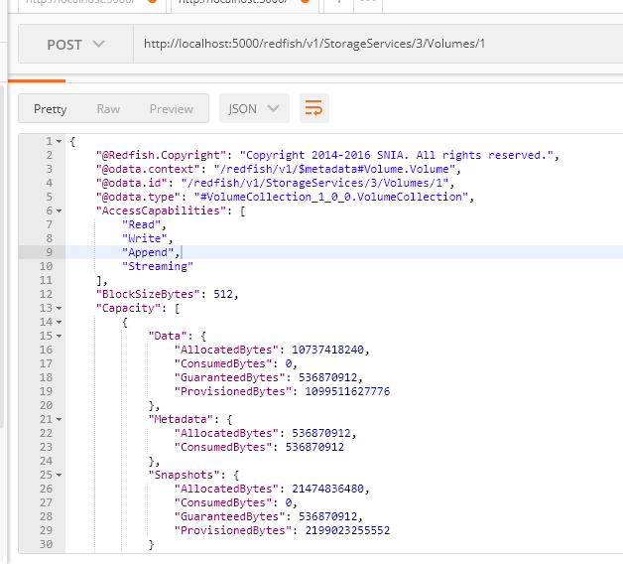

1. Edit volume collection using “PUT”

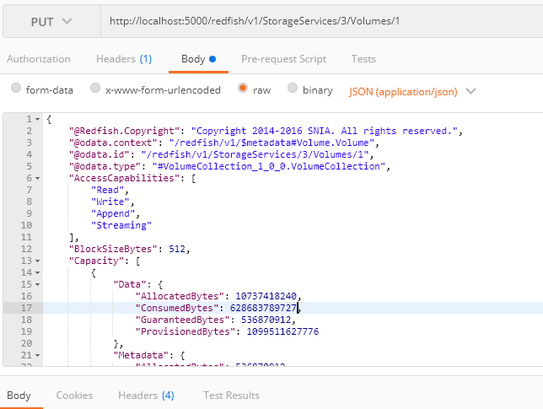

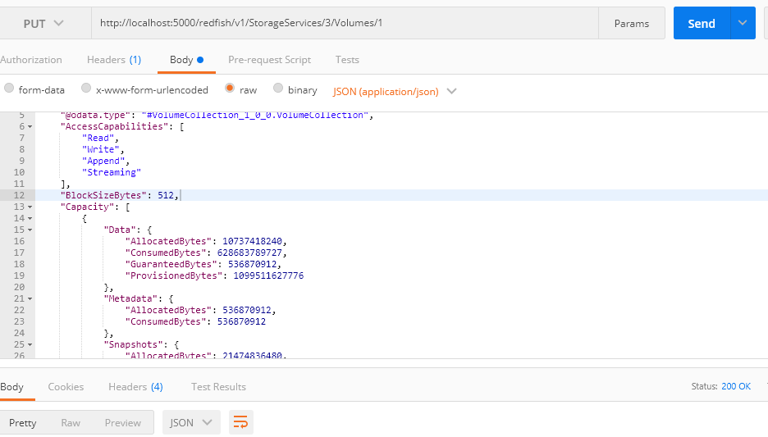

1. Deleting a Collection in “Volumes”

